Smart Materials
Part-A / 2-Marks
Answer the Following:
1.What is the Computer Network?
A computer network is a set of devices connected through links. A node can be computer, printer, or any other device capable of sending or receiving the data. The links connecting the nodes are known as communication channels.
2. What is called Internet?
The Internet is a vast network that connects computers all over the world. Through the Internet, people can share information and communicate from anywhere with an Internet connection.
3. What is Router?
A router is a device that connects two or more packet-switched networks or subnetworks. It serves two primary functions: managing traffic between these networks by forwarding data packets to their intended IP addresses, and allowing multiple devices to use the same Internet connection.
4. What is Data and Information?
Data is raw, unorganized facts that need to be processed. ... When data is processed, organized, structured or presented in a given context so as to make it useful, it is called information. Example. Each student's test score is one piece of data.
5. What is called network topology?
Network topology refers to the manner in which the links and nodes of a network are arranged to relate to each other. ... Physical network topology examples include star, mesh, tree, ring, point-to-point, circular, hybrid, and bus topology networks, each consisting of different configurations of nodes and links.
6. What are the uses of computer networks?
Computer networks support many applications and services, such as access to the World Wide Web, digital video, digital audio, shared use of application and storage servers, printers, and fax machines, and use of email and instant messaging applications.
7. Mention the types of Error.
These interferences can change the timing and shape of the signal. If the signal is carrying binary encoded data, such changes can alter the meaning of the data.
These errors can be divided into two types :
1. Single-bit error
2. Burst error.
8. What are the responsibilities of data link layer?
Data link layer mainly deals with framing, error control and flow control. Data link layer is the layer where the packets are encapsulated into frames.
9. What is called redundancy bit?
Redundant bits are extra binary digits that are generated and moved with a data transfer to ensure that no bits were lost during the data transfer. Redundant data can protect a storage array against data loss in the event of a hard disk failure.
10. What is Error detection?
In networking, error detection refers to the techniques used to detect noise or other impairments introduced into data while it is transmitted from source to destination. Error detection ensures reliable delivery of data across vulnerable networks.
Error detection minimizes the probability of passing incorrect frames to the destination, known as undetected error probability.
11. What is Flow of Control?
Flow control is a technique that allows two stations working at different speeds to communicate with each other. It is a set of measures taken to regulate the amount of data that a sender sends so that a fast sender does not overwhelm a slow receiver.
In data link layer, flow control restricts the number of frames the sender can send before it waits for an acknowledgment from the receiver.
12. What is Error correction?
Error Correction codes are used to detect and correct the errors when data is transmitted from the sender to the receiver.
Error Correction can be handled in two ways:
Forward error correction: In this case, the receiver uses the error-correcting code which automatically corrects the errors.
Backward error correction: Once the error is discovered, the receiver requests the sender to retransmit the entire data unit.
13. What is switching in computer networks? / What is switching and its types?
Switching is process to forward packets coming in from one port to a port leading towards the destination. When data comes on a port it is called ingress, and when data leaves a port or goes out it is called egress. A communication system may include number of switches and nodes. At broad level, switching can be divided into two major categories:
- Connectionless: The data is forwarded on behalf of forwarding tables. No previous handshaking is required and acknowledgements are optional.
- Connection Oriented: Before switching data to be forwarded to destination, there is a need to pre-establish circuit along the path between both endpoints. Data is then forwarded on that circuit. After the transfer is completed, circuits can be kept for future use or can be turned down immediately.
14. What is called Packet switching?
Packet switching is the transfer of small pieces of data across various networks. These data chunks or “packets” allow for faster, more efficient data transfer.
Often, when a user sends a file across a network, it gets transferred in smaller data packets, not in one piece. For example, a 3MB file will be divided into packets, each with a packet header that includes the origin IP address, the destination IP address, the number of packets in the entire data file, and the sequence number.
15. What is called Circuit switching?
Circuit switching is a connection-oriented network switching technique. Here, a dedicated route is established between the source and the destination and the entire message is transferred through it.
16. What is IPV6 used for?
Internet Protocol version 6 (IPv6) is the most recent version of the Internet Protocol (IP), the communications protocol that provides an identification and location system for computers on networks and routes traffic across the Internet. IPv6 is intended to replace IPv4.
17. What is IPV in networking?
Internet Protocol version is the communications protocol that provides an identification and location system for computers on networks and routes traffic across the Internet.
18. What are the advantages of circuit switching?
The main advantage of circuit switching is that a committed transmission channel is established between the computers which give a guaranteed data rate. In-circuit switching, there is no delay in data flow because of the dedicated transmission path.
19. What are switching techniques?
Switching Techniques are the techniques that are used and applied on a large network. Switching technique comes into picture when these large network needs to transfer the packet from source to destination i.e. from sender to receiver.
Part-B / 14-Marks
1. Explain in detail about Transmission media in Computer networks.
TRANSMISSION MEDIA
The transmission media is nothing but the physical media over which communication takes place in computer networks.

Magnetic Media
One of the most convenient way to transfer data from one computer to another, even before the birth of networking, was to save it on some storage media and transfer physical from one station to another. Though it may seem old-fashion way in today’s world of high speed internet, but when the size of data is huge, the magnetic media comes into play.
For example, a bank has to handle and transfer huge data of its customer, which stores a backup of it at some geographically far-away place for security reasons and to keep it from uncertain calamities. If the bank needs to store its huge backup data then its,transfer through internet is not feasible.The WAN links may not support such high speed.Even if they do; the cost too high to afford.
In these cases, data backup is stored onto magnetic tapes or magnetic discs, and then shifted physically at remote places.

Twisted Pair Cable
A twisted pair cable is made of two plastic insulated copper wires twisted together to form a single media. Out of these two wires, only one carries actual signal and another is used for ground reference. The twists between wires are helpful in reducing noise (electro-magnetic interference) and crosstalk.
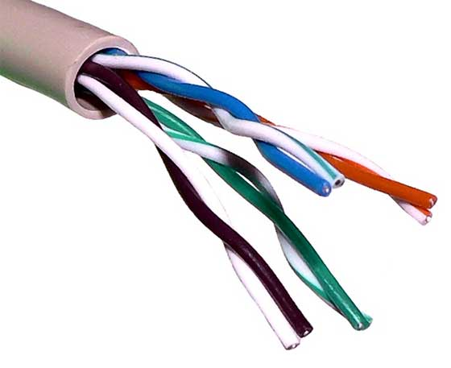
There are two types of twisted pair cables:
- Shielded Twisted Pair (STP) Cable
- Unshielded Twisted Pair (UTP) Cable
STP cables comes with twisted wire pair covered in metal foil. This makes it more indifferent to noise and crosstalk.
UTP has seven categories, each suitable for specific use. In computer networks, Cat-5, Cat-5e, and Cat-6 cables are mostly used. UTP cables are connected by RJ45 connectors.

Coaxial Cable
Coaxial cable has two wires of copper. The core wire lies in the center and it is made of solid conductor.The core is enclosed in an insulating sheath.The second wire is wrapped around over the sheath and that too in turn encased by insulator sheath.This all is covered by plastic cover.
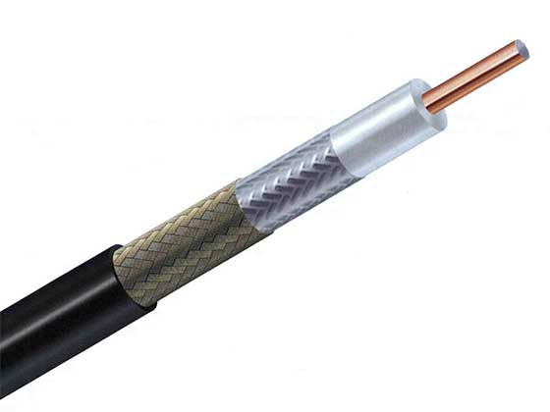
Because of its structure,the coax cable is capable of carrying high frequency signals than that of twisted pair cable.The wrapped structure provides it a good shield against noise and cross talk. Coaxial cables provide high bandwidth rates of up to 450 mbps.
There are three categories of coax cables namely, RG-59 (Cable TV), RG-58 (Thin Ethernet), and RG-11 (Thick Ethernet). RG stands for Radio Government.
Cables are connected using BNC connector and BNC-T. BNC terminator is used to terminate the wire at the far ends.

Power Lines
Power Line communication (PLC) is Layer-1 (Physical Layer) technology which uses power cables to transmit data signals.In PLC, modulated data is sent over the cables. The receiver on the other end de-modulates and interprets the data.
Because power lines are widely deployed, PLC can make all powered devices controlled and monitored. PLC works in half-duplex.
There are two types of PLC:
- Narrow band PLC
- Broad band PLC
Narrow band PLC provides lower data rates up to 100s of kbps, as they work at lower frequencies (3-5000 kHz).They can be spread over several kilometers.
Broadband PLC provides higher data rates up to 100s of Mbps and works at higher frequencies (1.8 – 250 MHz).They cannot be as much extended as Narrowband PLC.

Fiber Optics
Fiber Optic works on the properties of light. When light ray hits at critical angle it tends to refracts at 90 degree. This property has been used in fiber optic. The core of fiber optic cable is made of high quality glass or plastic. From one end of it light is emitted, it travels through it and at the other end light detector detects light stream and converts it to electric data.
Fiber Optic provides the highest mode of speed. It comes in two modes, one is single mode fiber and second is multimode fiber. Single mode fiber can carry a single ray of light whereas multimode is capable of carrying multiple beams of light.
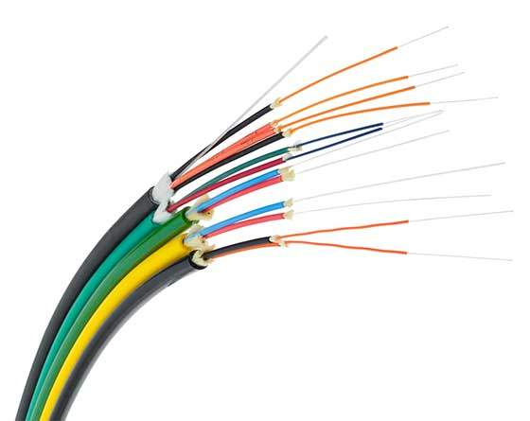
Fiber Optic also comes in unidirectional and bidirectional capabilities. To connect and access fiber optic special type of connectors are used. These can be Subscriber Channel (SC), Straight Tip (ST), or MT-RJ.
2. Explain in detail about OSI reference model.
OSI MODEL
OSI stands for Open Systems Interconnection. It has been developed by ISO – ‘International Organization of Standardization‘, in the year 1984. It is a 7 layer architecture with each layer having specific functionality to perform. All these 7 layers work collaboratively to transmit the data from one person to another across the globe.
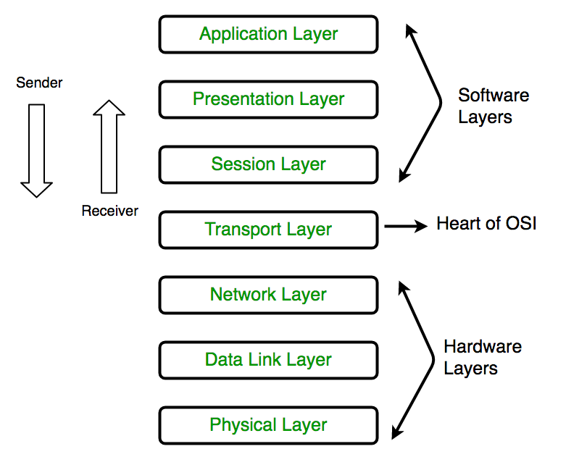
1. Physical Layer (Layer 1) :
The lowest layer of the OSI reference model is the physical layer. It is responsible for the actual physical connection between the devices. The physical layer contains information in the form of bits. It is responsible for transmitting individual bits from one node to the next. When receiving data, this layer will get the signal received and convert it into 0s and 1s and send them to the Data Link layer, which will put the frame back together.

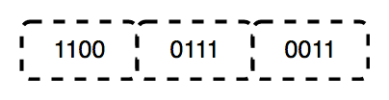
The functions of the physical layer are :
Bit synchronization: The physical layer provides the synchronization of the bits by providing a clock. This clock controls both sender and receiver thus providing synchronization at bit level.
Bit rate control: The Physical layer also defines the transmission rate i.e. the number of bits sent per second.
Physical topologies: Physical layer specifies the way in which the different, devices/nodes are arranged in a network i.e. bus, star, or mesh topology.
Transmission mode: Physical layer also defines the way in which the data flows between the two connected devices. The various transmission modes possible are Simplex, half-duplex and full-duplex.
* Hub, Repeater, Modem, Cables are Physical Layer devices.
** Network Layer, Data Link Layer, and Physical Layer are also known as Lower Layers or Hardware Layers.
2. Data Link Layer (DLL) (Layer 2) :
The data link layer is responsible for the node-to-node delivery of the message. The main function of this layer is to make sure data transfer is error-free from one node to another, over the physical layer. When a packet arrives in a network, it is the responsibility of DLL to transmit it to the Host using its MAC address.
Data Link Layer is divided into two sublayers:
- Logical Link Control (LLC)
- Media Access Control (MAC)
The packet received from the Network layer is further divided into frames depending on the frame size of NIC(Network Interface Card). DLL also encapsulates Sender and Receiver’s MAC address in the header.
The Receiver’s MAC address is obtained by placing an ARP(Address Resolution Protocol) request onto the wire asking “Who has that IP address?” and the destination host will reply with its MAC address.
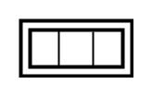

The functions of the Data Link layer are :
Framing: Framing is a function of the data link layer. It provides a way for a sender to transmit a set of bits that are meaningful to the receiver. This can be accomplished by attaching special bit patterns to the beginning and end of the frame.
Physical addressing: After creating frames, the Data link layer adds physical addresses (MAC address) of the sender and/or receiver in the header of each frame.
Error control: Data link layer provides the mechanism of error control in which it detects and retransmits damaged or lost frames.
Flow Control: The data rate must be constant on both sides else the data may get corrupted thus, flow control coordinates the amount of data that can be sent before receiving acknowledgement.
Access control: When a single communication channel is shared by multiple devices, the MAC sub-layer of the data link layer helps to determine which device has control over the channel at a given time.
* Packet in Data Link layer is referred to as Frame.
** Data Link layer is handled by the NIC (Network Interface Card) and device drivers of host machines.
*** Switch & Bridge are Data Link Layer devices.
3. Network Layer (Layer 3) :
The network layer works for the transmission of data from one host to the other located in different networks. It also takes care of packet routing i.e. selection of the shortest path to transmit the packet, from the number of routes available. The sender & receiver’s IP addresses are placed in the header by the network layer.
The functions of the Network layer are :
Routing: The network layer protocols determine which route is suitable from source to destination. This function of the network layer is known as routing.
Logical Addressing: In order to identify each device on internetwork uniquely, the network layer defines an addressing scheme. The sender & receiver’s IP addresses are placed in the header by the network layer. Such an address distinguishes each device uniquely and universally.
* Segment in Network layer is referred to as Packet.

** Network layer is implemented by networking devices such as routers.
4. Transport Layer (Layer 4) :
The transport layer provides services to the application layer and takes services from the network layer. The data in the transport layer is referred to as Segments. It is responsible for the End to End Delivery of the complete message. The transport layer also provides the acknowledgement of the successful data transmission and re-transmits the data if an error is found.
• At sender’s side:
Transport layer receives the formatted data from the upper layers, performs Segmentation, and also implements Flow & Error control to ensure proper data transmission. It also adds Source and Destination port numbers in its header and forwards the segmented data to the Network Layer.
Note: The sender needs to know the port number associated with the receiver’s application.
Generally, this destination port number is configured, either by default or manually. For example, when a web application makes a request to a web server, it typically uses port number 80, because this is the default port assigned to web applications. Many applications have default ports assigned.
• At receiver’s side:
Transport Layer reads the port number from its header and forwards the Data which it has received to the respective application. It also performs sequencing and reassembling of the segmented data.
The functions of the transport layer are :
Segmentation and Reassembly: This layer accepts the message from the (session) layer, breaks the message into smaller units. Each of the segments produced has a header associated with it. The transport layer at the destination station reassembles the message.
Service Point Addressing: In order to deliver the message to the correct process, the transport layer header includes a type of address called service point address or port address. Thus by specifying this address, the transport layer makes sure that the message is delivered to the correct process.
The services provided by the transport layer :
Connection-Oriented Service: It is a three-phase process that includes
– Connection Establishment
– Data Transfer
– Termination / disconnection
In this type of transmission, the receiving device sends an acknowledgement, back to the source after a packet or group of packets is received. This type of transmission is reliable and secure.
Connectionless service: It is a one-phase process and includes Data Transfer. In this type of transmission, the receiver does not acknowledge receipt of a packet. This approach allows for much faster communication between devices. Connection-oriented service is more reliable than connectionless Service.
* Data in the Transport Layer is called as Segments.
** Transport layer is operated by the Operating System. It is a part of the OS and communicates with the Application Layer by making system calls.
Transport Layer is called as Heart of OSI model.
5. Session Layer (Layer 5) :
This layer is responsible for the establishment of connection, maintenance of sessions, authentication, and also ensures security.
The functions of the session layer are :
Session establishment, maintenance, and termination: The layer allows the two processes to establish, use and terminate a connection.
Synchronization: This layer allows a process to add checkpoints which are considered synchronization points into the data. These synchronization points help to identify the error so that the data is re-synchronized properly, and ends of the messages are not cut prematurely and data loss is avoided.
Dialog Controller: The session layer allows two systems to start communication with each other in half-duplex or full-duplex.
**All the below 3 layers(including Session Layer) are integrated as a single layer in the TCP/IP model as “Application Layer”.
**Implementation of these 3 layers is done by the network application itself. These are also known as Upper Layers or Software Layers.
SCENARIO:
Let’s consider a scenario where a user wants to send a message through some Messenger application running in his browser. The “Messenger” here acts as the application layer which provides the user with an interface to create the data. This message or so-called Data is compressed, encrypted (if any secure data), and converted into bits (0’s and 1’s) so that it can be transmitted.
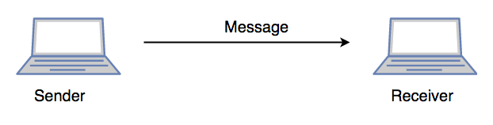
6. Presentation Layer (Layer 6) :
The presentation layer is also called the Translation layer. The data from the application layer is extracted here and manipulated as per the required format to transmit over the network.
The functions of the presentation layer are :
Translation: For example, ASCII to EBCDIC.
Encryption/ Decryption: Data encryption translates the data into another form or code. The encrypted data is known as the ciphertext and the decrypted data is known as plain text. A key value is used for encrypting as well as decrypting data.
Compression: Reduces the number of bits that need to be transmitted on the network.
7. Application Layer (Layer 7) :
At the very top of the OSI Reference Model stack of layers, we find the Application layer which is implemented by the network applications. These applications produce the data, which has to be transferred over the network. This layer also serves as a window for the application services to access the network and for displaying the received information to the user.
Ex: Application – Browsers, Skype Messenger, etc.
**Application Layer is also called Desktop Layer.

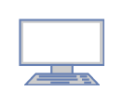
The functions of the Application layer are :
Network Virtual Terminal
FTAM-File transfer access and management
Mail Services
Directory Services
OSI model acts as a reference model and is not implemented on the Internet because of its late invention. The current model being used is the TCP/IP model.
3. Explain in detail about Hamming code with an example.

Hamming Code:
Parity bits: A bit that is added to the original binary data to make sure the total number of 1s is even or odd (in case of even or odd parity respectively).
Even parity: To check for even parity, if the total number of 1s is even, the parity bit value is 0. If the total number of occurrences of 1s is odd, the parity bit value is 1.

Odd Parity: To test for odd parity, if the total number of 1s is even, the parity bit value is 1. If the total number of 1s is odd, the parity bit value is 0.

- To produce d+r, an information of ‘d’ bits is added to the redundant bits ‘r’.
- Each (d+r) digit’s position is assigned a decimal value.
- The ‘r’ bits are assigned to locations 1, 2,….2k-1.
- The parity bits are recalculated at the receiving end. The position of an error is determined by the decimal value of the parity bits.
- Example: If the data to be transmitted is 1011001
- Number of data bits = 7
- Thus, number of redundancy bits = 4
- Total bits = 7+4 = 11
- Redundant bits are always placed at positions that correspond to the power of 2, so the redundant bits will be placed at positions: 1,2,4 and 8.
Redundant bits will be placed here:
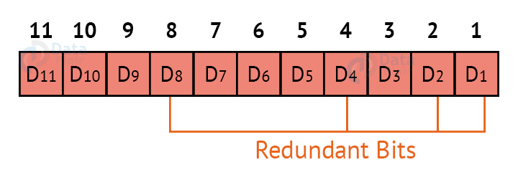
Thus now, all the 11 bits will look like this:
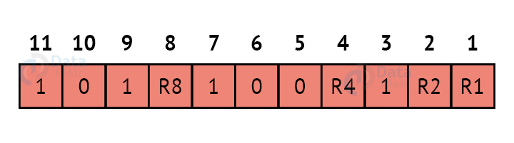
Here, R1, R2, R4 and R8 are the redundant bits.

Determining the parity bits:

R1:
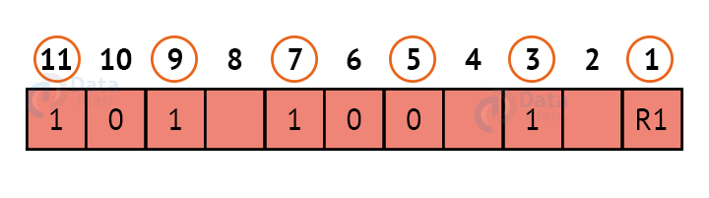
We look at bits 1,3,5,7,9,11 to calculate R1. In this case, because the number of 1s in these bits together is even, we make the R1 bit equal to 0 to maintain even parity.

R2:
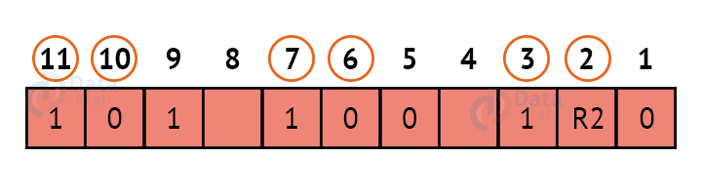
We look at bits 2,3,6,7,10,11 to calculate R2. In this case, because the number of 1s in these bits together is odd, we make the R2 bit equal to 1 to maintain even parity.

R4:
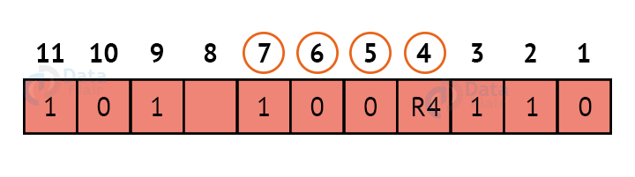
We look at bits 4,5,6,7 to calculate R4. In this case, because the number of 1s in these bits together is odd, we make the R4 bit equal to 1 to maintain even parity.

R8:
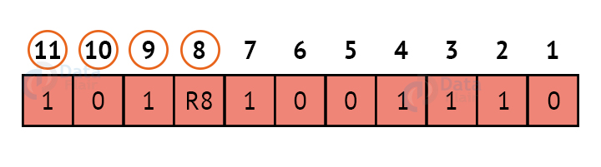
We look at bits 8,9,10,11 to calculate R8. In this case, because the number of 1s in these bits together is even, we make the R8 bit equal to 0 to maintain even parity. Thus, the final block of data which is transferred looks like this:
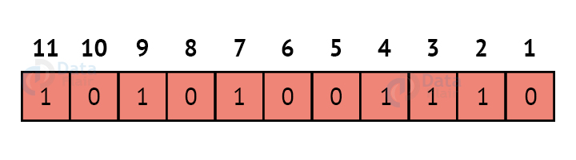
4. Explain in detail about CRC with an example.

Cyclic Redundancy Check (CRC)
CRC is a redundancy error technique used to determine the error.
Following are the steps used in CRC for error detection:
- In CRC technique, a string of n 0s is appended to the data unit, and this n number is less than the number of bits in a predetermined number, known as division which is n+1 bits.
- Secondly, the newly extended data is divided by a divisor using a process is known as binary division. The remainder generated from this division is known as CRC remainder.
- Thirdly, the CRC remainder replaces the appended 0s at the end of the original data. This newly generated unit is sent to the receiver.
- The receiver receives the data followed by the CRC remainder. The receiver will treat this whole unit as a single unit, and it is divided by the same divisor that was used to find the CRC remainder.
If the resultant of this division is zero which means that it has no error, and the data is accepted.
If the resultant of this division is not zero which means that the data consists of an error. Therefore, the data is discarded.
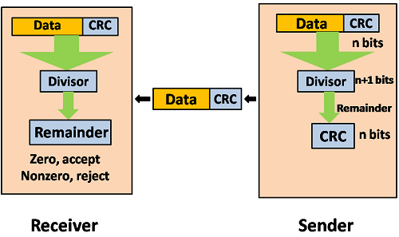
Let's understand this concept through an example:
Suppose the original data is 11100 and divisor is 1001.

CRC Generator
- A CRC generator uses a modulo-2 division. Firstly, three zeroes are appended at the end of the data as the length of the divisor is 4 and we know that the length of the string 0s to be appended is always one less than the length of the divisor.
- Now, the string becomes 11100000, and the resultant string is divided by the divisor 1001.
- The remainder generated from the binary division is known as CRC remainder. The generated value of the CRC remainder is 111.
- CRC remainder replaces the appended string of 0s at the end of the data unit, and the final string would be 11100111 which is sent across the network.
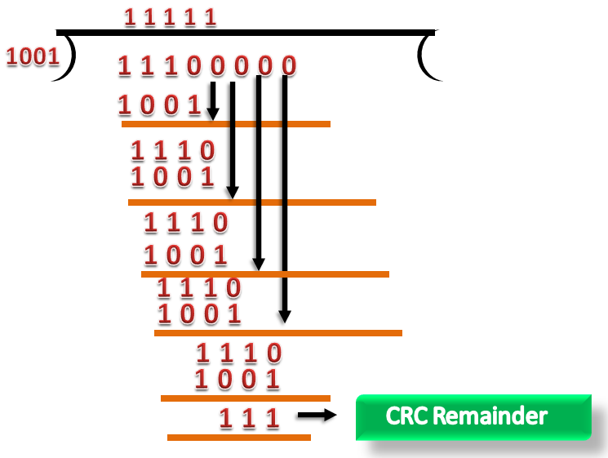

CRC Checker
- The functionality of the CRC checker is similar to the CRC generator.
- When the string 11100111 is received at the receiving end, then CRC checker performs the modulo-2 division.
- A string is divided by the same divisor, i.e., 1001.
- In this case, CRC checker generates the remainder of zero. Therefore, the data is accepted.
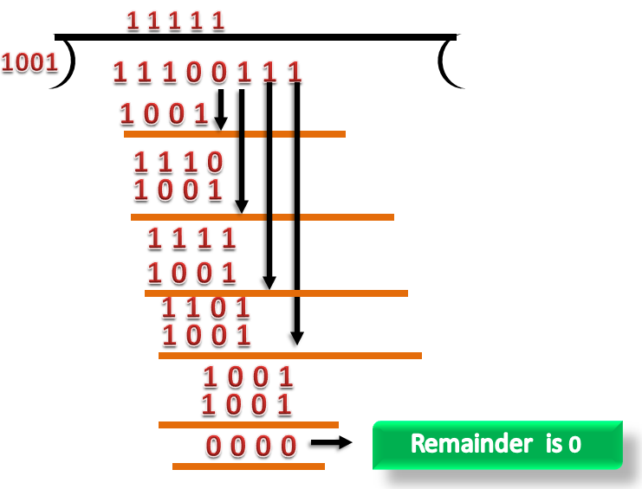

5. Explain Error detection and Error correction with an example.

Error Detection And Correction in Computer Network
An error occurs when the output information does not match the input information. Digital signals suffer from noise during transmission, which can create errors in binary bits travelling from one system to another. That is, a 0 bit may become a 1 bit, or a 1 bit may become a 0.
Many factors, including noise and cross-talk, can contribute to data corruption during transmission. The top layers are unaware of real hardware data processing and work on a generic picture of network architecture. As a result, the top levels anticipate error-free transmission between the systems.
Most programs would not work normally if they received incorrect data. Voice and video applications, for example, may be unaffected and continue to work normally despite occasional problems.

Error Detection:
When a message is sent, it may be jumbled by noise or the data may be damaged. To avoid this, we employ error-detecting codes, which are bits of extra data appended to a digital message to assist us detect whether an error occurred during transmission.

Error Detection Techniques:

1. Simple Parity Check:
- One extra bit is transmitted in addition to the original bits to make the number of 1s even in the case of even parity or odd in the case of odd parity.
- While creating a frame, the sender counts the amount of 1s in it. If even parity is utilised and the number of 1s is even, one bit with the value 0 is added. In this manner, the number of 1s remains even. If the number of 1s is odd, a value 1 is added to make it even.
- The receiver just counts how many 1s are in a frame. If the number of 1s is even and even parity is utilised, the frame is regarded as uncorrupted and approved. Even if the number of 1s is odd and odd parity is utilised, the frame is not damaged.
- The receiver can identify a single bit flip in transit by counting the number of 1s. However, when more than one bit is incorrect, it is extremely difficult for the receiver to identify the problem.
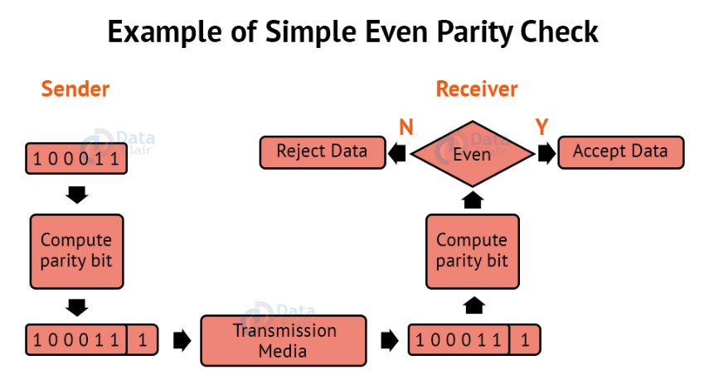

Checksum:
The data is split into k segments of m bits each in the checksum error detection technique.
To get the total, the segments are summed at the sender’s end using 1’s complement arithmetic. To obtain the checksum, a complement of the sum is taken.
The checksum segment is sent with the data segments.
To obtain the total, all received segments are summed using 1’s complement arithmetic at the receiver’s end. The sum is then calculated.
If the result is 0, the data is accepted; otherwise, it is rejected.
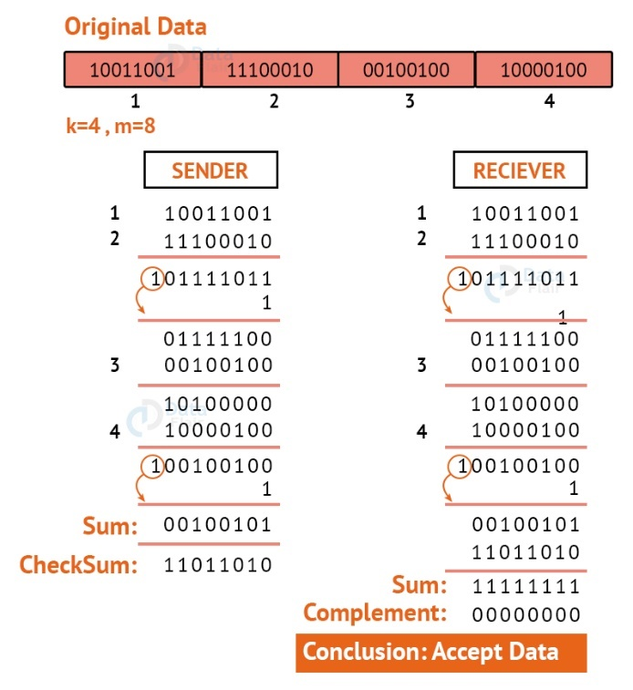

4. Cyclic Redundancy Check:
CRC is an alternative method for determining whether or not a received frame includes valid data. The binary division of the data bits being delivered is used in this approach. Polynomials are used to generate the divisor.
The sender divides the bits that are being transferred and calculates the remainder. The sender inserts the remainder at the end of the original bits before sending the actual bits. A codeword is made up of the actual data bits plus the remainder. The transmitter sends data bits in the form of codewords.
The receiver, on the other hand, divides the codewords using the same CRC divisor. If the remainder consists entirely of zeros, the data bits are validated; otherwise, it is assumed that some data corruption happened during transmission.
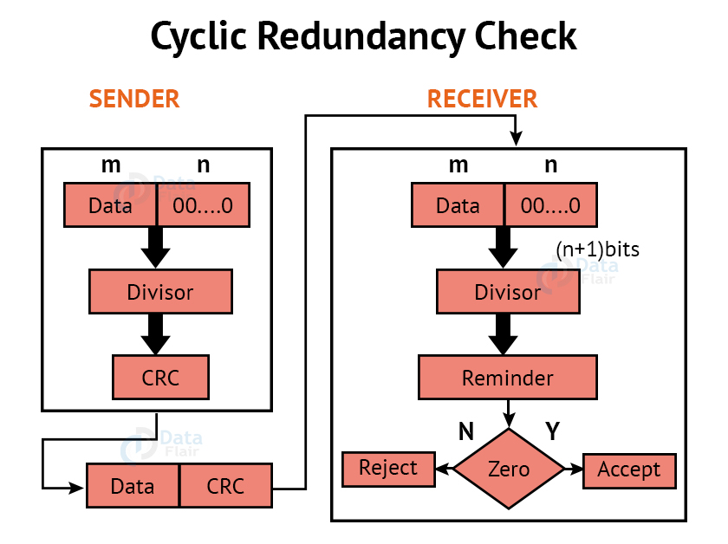

Error Correction:
Error Correction codes are used to detect and repair mistakes that occur during data transmission from the transmitter to the receiver.
There are two approaches to error correction:

1. Backward Error Correction:
When a backward mistake is detected, the receiver requests that the sender retransmit the complete data unit.

2. Forward Error Correction:
In this scenario, the error-correcting code is used by the receiver, which automatically corrects the mistakes.
A single extra bit can identify but not repair the mistake.
To correct the mistakes, the specific location of the error must be known. If we wish to compute a single-bit mistake, for example, the error correcting algorithm will identify which one of seven bits is incorrect. We will need to add some more redundant bits to do this.
The number of redundant bits is calculated using the following formula:
2^{r}>=d+r+1

The above formula is used to compute the value of r. For example, if the value of d is 4, the least possible number that fulfils the above relation is 3.

Error Correction Techniques:

1. Hamming Code:
Parity bits: A bit that is added to the original binary data to make sure the total number of 1s is even or odd (in case of even or odd parity respectively).
Even parity: To check for even parity, if the total number of 1s is even, the parity bit value is 0. If the total number of occurrences of 1s is odd, the parity bit value is 1.

Odd Parity: To test for odd parity, if the total number of 1s is even, the parity bit value is 1. If the total number of 1s is odd, the parity bit value is 0.

- To produce d+r, an information of ‘d’ bits is added to the redundant bits ‘r’.
- Each (d+r) digit’s position is assigned a decimal value.
- The ‘r’ bits are assigned to locations 1, 2,….2k-1.
- The parity bits are recalculated at the receiving end. The position of an error is determined by the decimal value of the parity bits.
- Example: If the data to be transmitted is 1011001
- Number of data bits = 7
- Thus, number of redundancy bits = 4
- Total bits = 7+4 = 11
- Redundant bits are always placed at positions that correspond to the power of 2, so the redundant bits will be placed at positions: 1,2,4 and 8.
Redundant bits will be placed here:
Thus now, all the 11 bits will look like this:
Here, R1, R2, R4 and R8 are the redundant bits.

Determining the parity bits:

R1:
We look at bits 1,3,5,7,9,11 to calculate R1. In this case, because the number of 1s in these bits together is even, we make the R1 bit equal to 0 to maintain even parity.

R2:
We look at bits 2,3,6,7,10,11 to calculate R2. In this case, because the number of 1s in these bits together is odd, we make the R2 bit equal to 1 to maintain even parity.

R4:
We look at bits 4,5,6,7 to calculate R4. In this case, because the number of 1s in these bits together is odd, we make the R4 bit equal to 1 to maintain even parity.

R8:
We look at bits 8,9,10,11 to calculate R8. In this case, because the number of 1s in these bits together is even, we make the R8 bit equal to 0 to maintain even parity. Thus, the final block of data which is transferred looks like this:
6. Explain in detail about the functions of data link layer.
DATA LINK LAYER
Data Link Layer is second layer of OSI Layered Model. This layer is one of the most complicated layers and has complex functionalities and liabilities. Data link layer hides the details of underlying hardware and represents itself to upper layer as the medium to communicate.
Data link layer works between two hosts which are directly connected in some sense. This direct connection could be point to point or broadcast. Systems on broadcast network are said to be on same link. The work of data link layer tends to get more complex when it is dealing with multiple hosts on single collision domain.
Data link layer is responsible for converting data stream to signals bit by bit and to send that over the underlying hardware. At the receiving end, Data link layer picks up data from hardware which are in the form of electrical signals, assembles them in a recognizable frame format, and hands over to upper layer.
Data link layer has two sub-layers:
- Logical Link Control: It deals with protocols, flow-control, and error control
- Media Access Control: It deals with actual control of media

Functionality of Data-link Layer
Data link layer does many tasks on behalf of upper layer. These are:
- Framing
Data-link layer takes packets from Network Layer and encapsulates them into Frames.Then, it sends each frame bit-by-bit on the hardware. At receiver’ end, data link layer picks up signals from hardware and assembles them into frames.
- Addressing
Data-link layer provides layer-2 hardware addressing mechanism. Hardware address is assumed to be unique on the link. It is encoded into hardware at the time of manufacturing.
- Synchronization
When data frames are sent on the link, both machines must be synchronized in order to transfer to take place.
- Error Control
Sometimes signals may have encountered problem in transition and the bits are flipped. These errors are detected and attempted to recover actual data bits. It also provides error reporting mechanism to the sender.
- Flow Control
Stations on same link may have different speed or capacity. Data-link layer ensures flow control that enables both machine to exchange data on same speed.
- Multi-Access
When host on the shared link tries to transfer the data, it has a high probability of collision. Data-link layer provides mechanism such as CSMA/CD to equip capability of accessing a shared media among multiple Systems.
7. Explain in detail about Packet switching and Circuit switching.

Circuit Switching
- Circuit switching is a switching technique that establishes a dedicated path between sender and receiver.
- In the Circuit Switching Technique, once the connection is established then the dedicated path will remain to exist until the connection is terminated.
- Circuit switching in a network operates in a similar way as the telephone works.
- A complete end-to-end path must exist before the communication takes place.
- In case of circuit switching technique, when any user wants to send the data, voice, video, a request signal is sent to the receiver then the receiver sends back the acknowledgment to ensure the availability of the dedicated path. After receiving the acknowledgment, dedicated path transfers the data.
- Circuit switching is used in public telephone network. It is used for voice transmission.
- Fixed data can be transferred at a time in circuit switching technology.
Communication through circuit switching has 3 phases:
Where to interact with an IO Operative's Computer in Fortnite
- Circuit establishment
- Data transfer
- Circuit Disconnect
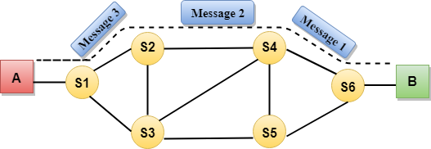
Circuit Switching can use either of the two technologies:

Space Division Switches:
- Space Division Switching is a circuit switching technology in which a single transmission path is accomplished in a switch by using a physically separate set of crosspoints.
- Space Division Switching can be achieved by using crossbar switch. A crossbar switch is a metallic crosspoint or semiconductor gate that can be enabled or disabled by a control unit.
- The Crossbar switch is made by using the semiconductor. For example, Xilinx crossbar switch using FPGAs.
- Space Division Switching has high speed, high capacity, and nonblocking switches.
Space Division Switches can be categorized in two ways:
- Crossbar Switch
- Multistage Switch

Crossbar Switch
The Crossbar switch is a switch that has n input lines and n output lines. The crossbar switch has n² intersection points known as crosspoints.
Disadvantage of Crossbar switch:
The number of crosspoints increases as the number of stations is increased. Therefore, it becomes very expensive for a large switch. The solution to this is to use a multistage switch.

Multistage Switch
- Multistage Switch is made by splitting the crossbar switch into the smaller units and then interconnecting them.
- It reduces the number of crosspoints.
- If one path fails, then there will be an availability of another path.
Advantages Of Circuit Switching:
- In the case of Circuit Switching technique, the communication channel is dedicated.
- It has fixed bandwidth.
Disadvantages Of Circuit Switching:
- Once the dedicated path is established, the only delay occurs in the speed of data transmission.
- It takes a long time to establish a connection approx 10 seconds during which no data can be transmitted.
- It is more expensive than other switching techniques as a dedicated path is required for each connection.
- It is inefficient to use because once the path is established and no data is transferred, then the capacity of the path is wasted.
- In this case, the connection is dedicated therefore no other data can be transferred even if the channel is free.

Packet Switching
- The packet switching is a switching technique in which the message is sent in one go, but it is divided into smaller pieces, and they are sent individually.
- The message splits into smaller pieces known as packets and packets are given a unique number to identify their order at the receiving end.
- Every packet contains some information in its headers such as source address, destination address and sequence number.
- Packets will travel across the network, taking the shortest path as possible.
- All the packets are reassembled at the receiving end in correct order.
- If any packet is missing or corrupted, then the message will be sent to resend the message.
- If the correct order of the packets is reached, then the acknowledgment message will be sent.
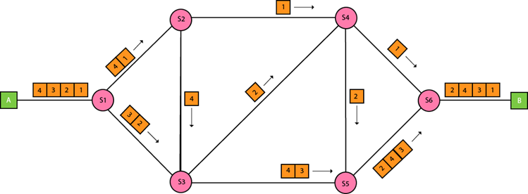

Approaches Of Packet Switching:
There are two approaches to Packet Switching:

Datagram Packet switching:
- It is a packet switching technology in which packet is known as a datagram, is considered as an independent entity. Each packet contains the information about the destination and switch uses this information to forward the packet to the correct destination.
- The packets are reassembled at the receiving end in correct order.
- In Datagram Packet Switching technique, the path is not fixed.
- Intermediate nodes take the routing decisions to forward the packets.
- Datagram Packet Switching is also known as connectionless switching.
8. Explain in detail about IPV4.
IPv4 is a version 4 of IP. It is a current version and the most commonly used IP address. It is a 32-bit address written in four numbers separated by 'dot', i.e., periods. This address is unique for each device.
For example, 66.94.29.13
The above example represents the IP address in which each group of numbers separated by periods is called an Octet. Each number in an octet is in the range from 0-255. This address can produce 4,294,967,296 possible unique addresses.
In today's computer network world, computers do not understand the IP addresses in the standard numeric format as the computers understand the numbers in binary form only. The binary number can be either 1 or 0. The IPv4 consists of four sets, and these sets represent the octet. The bits in each octet represent a number.
Each bit in an octet can be either 1 or 0. If the bit the 1, then the number it represents will count, and if the bit is 0, then the number it represents does not count.
Representation of 8 Bit Octet
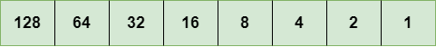
The above representation shows the structure of 8- bit octet.
Now, we will see how to obtain the binary representation of the above IP address, i.e., 66.94.29.13
Step 1: First, we find the binary number of 66.
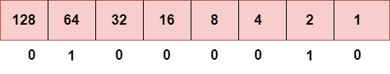
To obtain 66, we put 1 under 64 and 2 as the sum of 64 and 2 is equal to 66 (64+2=66), and the remaining bits will be zero, as shown above. Therefore, the binary bit version of 66 is 01000010.
Step 2: Now, we calculate the binary number of 94.
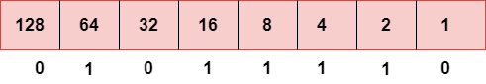
To obtain 94, we put 1 under 64, 16, 8, 4, and 2 as the sum of these numbers is equal to 94, and the remaining bits will be zero. Therefore, the binary bit version of 94 is 01011110.
Step 3: The next number is 29.
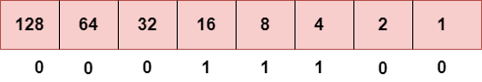
To obtain 29, we put 1 under 16, 8, 4, and 1 as the sum of these numbers is equal to 29, and the remaining bits will be zero. Therefore, the binary bit version of 29 is 00011101.
Step 4: The last number is 13.
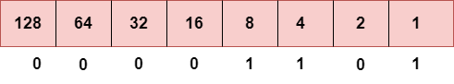
To obtain 13, we put 1 under 8, 4, and 1 as the sum of these numbers is equal to 13, and the remaining bits will be zero. Therefore, the binary bit version of 13 is 00001101.

IPv4 - Packet Structure
Internet Protocol being a layer-3 protocol (OSI) takes data Segments from layer-4 (Transport) and divides it into packets. IP packet encapsulates data unit received from above layer and add to its own header information.
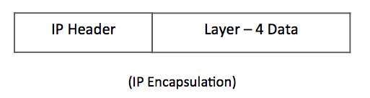
The encapsulated data is referred to as IP Payload. IP header contains all the necessary information to deliver the packet at the other end.
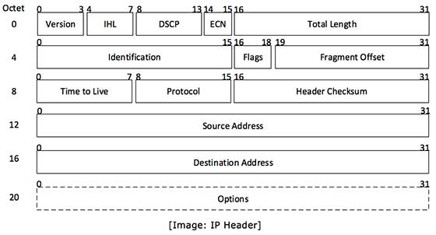
IP header includes many relevant information including Version Number, which, in this context, is 4. Other details are as follows −
- Version − Version no. of Internet Protocol used (e.g. IPv4).
- IHL − Internet Header Length; Length of entire IP header.
- DSCP − Differentiated Services Code Point; this is Type of Service.
- ECN − Explicit Congestion Notification; It carries information about the congestion seen in the route.
- Total Length − Length of entire IP Packet (including IP header and IP Payload).
- Identification − If IP packet is fragmented during the transmission, all the fragments contain same identification number. to identify original IP packet they belong to.
- Flags − As required by the network resources, if IP Packet is too large to handle, these ‘flags’ tells if they can be fragmented or not. In this 3-bit flag, the MSB is always set to ‘0’.
- Fragment Offset − This offset tells the exact position of the fragment in the original IP Packet.
- Time to Live − To avoid looping in the network, every packet is sent with some TTL value set, which tells the network how many routers (hops) this packet can cross. At each hop, its value is decremented by one and when the value reaches zero, the packet is discarded.
- Protocol − Tells the Network layer at the destination host, to which Protocol this packet belongs to, i.e. the next level Protocol. For example protocol number of ICMP is 1, TCP is 6 and UDP is 17.
- Header Checksum − This field is used to keep checksum value of entire header which is then used to check if the packet is received error-free.
- Source Address − 32-bit address of the Sender (or source) of the packet.
- Destination Address − 32-bit address of the Receiver (or destination) of the packet.
- Options − This is optional field, which is used if the value of IHL is greater than 5. These options may contain values for options such as Security, Record Route, Time Stamp, etc.

Drawback of IPv4
Currently, the population of the world is 7.6 billion. Every user is having more than one device connected with the internet, and private companies also rely on the internet.
As we know that IPv4 produces 4 billion addresses, which are not enough for each device connected to the internet on a planet.
Although the various techniques were invented, such as variable- length mask, network address translation, port address translation, classes, inter-domain translation, to conserve the bandwidth of IP address and slow down the depletion of an IP address. In these techniques, public IP is converted into a private IP due to which the user having public IP can also use the internet.
But still, this was not so efficient, so it gave rise to the development of the next generation of IP addresses, i.e., IPv6.
9. Explain in detail about IPV6.
IPv4 produces 4 billion addresses, and the developers think that these addresses are enough, but they were wrong. IPv6 is the next generation of IP addresses.
The main difference between IPv4 and IPv6 is the address size of IP addresses. The IPv4 is a 32-bit address, whereas IPv6 is a 128-bit hexadecimal address.
IPv6 provides a large address space, and it contains a simple header as compared to IPv4.
It provides transition strategies that convert IPv4 into IPv6, and these strategies are as follows:
- Dual stacking: It allows us to have both the versions, i.e., IPv4 and IPv6, on the same device.
- Tunneling: In this approach, all the users have IPv6 communicates with an IPv4 network to reach IPv6.
- Network Address Translation: The translation allows the communication between the hosts having a different version of IP.
This hexadecimal address contains both numbers and alphabets. Due to the usage of both the numbers and alphabets, IPv6 is capable of producing over 340 undecillion (3.4*10³⁸) addresses.
IPv6 is a 128-bit hexadecimal address made up of 8 sets of 16 bits each, and these 8 sets are separated by a colon. In IPv6, each hexadecimal character represents 4 bits. So, we need to convert 4 bits to a hexadecimal number at a time

Address format
The address format of IPv4:
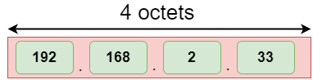
The address format of IPv6:
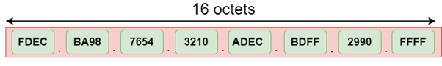
The above diagram shows the address format of IPv4 and IPv6. An IPv4 is a 32-bit decimal address. It contains 4 octets or fields separated by 'dot', and each field is 8-bit in size. The number that each field contains should be in the range of 0-255. Whereas an IPv6 is a 128-bit hexadecimal address. It contains 8 fields separated by a colon, and each field is 16-bit in size.

Packet Format of IPv6
The IPv6 packet is shown in the diagram. Each packet is composed of base header and the payload. The payload consists of two fields, optional extension headers and the data from upper layer.
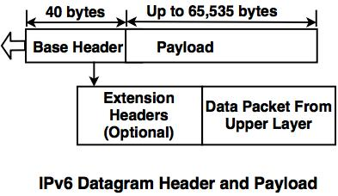
The Base header consists of eight fields:
1. Version : This is 4 bit field, which defines the version number of an IP and its value is 6 for IPv6.
2. Priority : This is 4 bit field, which defines the priority of the packet with respect to the traffic congestion.
3. Flow label : This is 24 bit field, which is designed to provide facility of specially handling the specific flow of the data.
4. Payload length : This is 16 bit field, which defines the length of an IP datagram excluding the base header.
5. Next header : This is 8 bit field, which defines the header that follows the base header in the datagram.
6. Hop limit : This is 8 bit field, which serves the same purpose as the TTL( Time to Live field in IPv4) field. It is a mechanism that limits the life span of the data in computer networks.
7. Source address : This is 128 bit source address field, which identifies the original source of the datagram.
8. Destination address : It is 128 bit destination address field, which identifies the original destination of the datagram
10. Explain in detail about IP address.
An IP address is the identifier that enables your device to send or receive data packets across the internet. It holds information related to your location and therefore making devices available for two-way communication.
The internet requires a process to distinguish between different networks, routers, and websites. Therefore, IP addresses provide the mechanism of doing so, and it forms an indispensable part in the working of the internet. You will notice that most of the IP addresses are essentially numerical. Still, as the world is witnessing a colossal growth of network users, the network developers had to add letters and some addresses as internet usage grows.
An IP address is represented by a series of numbers segregated by periods(.). They are expressed in the form of four pairs - an example address might be 255.255.255.255 wherein each set can range from 0 to 255.
IP addresses are not produced randomly. They are generated mathematically and are further assigned by the IANA (Internet Assigned Numbers Authority), a department of the ICANN.
ICANN stands for Internet Corporation for Assigned Names and Numbers. It is a non-profit corporation founded in the US back in 1998 with an aim to manage Internet security and enable it to be available by all.

How do IP addresses work?
Sometimes your device doesn't connect to your network the way you expect it to be, or you wish to troubleshoot why your network is not operating correctly. To answer the above questions, it is vital to learn the process with which IP addresses work.
Internet Protocol or IP runs the same manner as other languages, i.e., applying the set guidelines to communicate the information. All devices obtain, send, and pass information with other associated devices with the help of this protocol only. By using the same language, the computers placed anywhere can communicate with one another.
The process of IP address works in the following way:
- Your computer, smartphone, or any other Wi-Fi-enabled device firstly connects to a network that is further connected to the internet. The network is responsible for giving your device access to the internet.
- While working from home, your device would be probably using that network provided by your Internet Service Provider (ISP). In a professional environment, your device uses your company network.
- Your ISP is responsible to generate the IP address for your device.
- Your internet request penetrates through the ISP, and they place the requested data back to your device using your IP address. Since they provide you access to the internet, ISP's are responsible for allocating an IP address to your computer or respective device.
- Your IP address is never consistent and can change if there occurs any changes in its internal environment. For instance, if you turn your modem or router on or off, it will change your IP address. Or the user can also connect the ISP to change their IP address.
- When you are out of your home or office, mainly if you travel and carry your device with you, your computer won't be accessing your home IP address anymore. This is because you will be accessing the different networks (your phone hotspot, Wi-Fi at a cafe, resort, or airport, etc.) to connect the device with the internet. Therefore, your device will be allocated a different (temporary) IP address by the ISP of the hotel or cafe.

Types of IP addresses
There are various classifications of IP addresses, and each category further contains some types.

Consumer IP addresses
Every individual or firm with an active internet service system pursues two types of IP addresses, i.e., Private IP (Internet Protocol) addresses and public IP (Internet Protocol) addresses.
The public and private correlate to the network area. Therefore, a private IP address is practiced inside a network, whereas the other (public IP address) is practiced outside a network.
1. Private IP addresses
All the devices that are linked with your internet network are allocated a private IP address. It holds computers, desktops, laptops, smartphones, tablets, or even Wi-Fi-enabled gadgets such as speakers, printers, or smart Televisions. With the expansion of IoT (internet of things), the demand for private IP addresses at individual homes is also seemingly growing.
However, the router requires a method to identify these things distinctly. Therefore, your router produces unique private IP addresses that act as an identifier for every device using your internet network. Thus, differentiating them from one another on the network.
2. Public IP addresses
A public IP address or primary address represents the whole network of devices associated with it. Every device included within with your primary address contains their own private IP address.
ISP is responsible to provide your public IP address to your router. Typically, ISPs contains the bulk stock of IP addresses that they dispense to their clients. Your public IP address is practiced by every device to identify your network that is residing outside your internet network.
Public IP addresses are further classified into two categories- dynamic and static.
- Dynamic IP addresses
As the name suggests, Dynamic IP addresses change automatically and frequently. With this types of IP address, ISPs already purchase a bulk stock of IP addresses and allocate them in some order to their customers. Periodically, they re-allocate the IP addresses and place the used ones back into the IP addresses pool so they can be used later for another client. The foundation for this method is to make cost savings profits for the ISP.
- Static IP addresses
In comparison to dynamic IP addresses, static addresses are constant in nature. The network assigns the IP address to the device only once and, it remains consistent. Though most firms or individuals do not prefer to have a static IP address, it is essential to have a static IP address for an organization that wants to host its network server. It protects websites and email addresses linked with it with a constant IP address.

Types of website IP addresses
The following classification is segregated into the two types of website IP addresses i.e., shared and dedicated.
1. Shared IP addresses
Many startups or individual website makers or various SME websites who don't want to invest initially in dedicated IP addresses can opt for shared hosting plans.
Various web hosting providers are there in the market providing shared hosting services where two or more websites are hosted on the same server.
Shared hosting is only feasible for websites that receive average traffic, the volumes are manageable, and the websites themselves are confined in terms of the webpages, etc.
2. Dedicated IP addresses
Web hosting providers also provide the option to acquire a dedicated IP address. Undoubtedly dedicated IP addresses are more secure, and they permit the users to run their File Transfer Protocol (FTP) server.
Therefore, it is easier to share and transfer data with many people within a business, and it also provides the option of anonymous FTP sharing. Another advantage of a dedicated IP addresses it the user can easily access the website using the IP address rather than typing the full domain name.

How to search for IP addresses
The easiest method to find the public IP address of your router is to type "What is my IP address?" on Google.com. Google will immediately display the results on the screen.
There are some third-party websites available on the internet that also provides the same information. Those websites can access your public IP address because your router has requested to access their information by visiting their website.
Below are the steps to find your private IP address in two commonly used platforms:
In Windows:
- Open the command prompt by typing the term 'cmd' (no quote marks) in the Windows search panel.
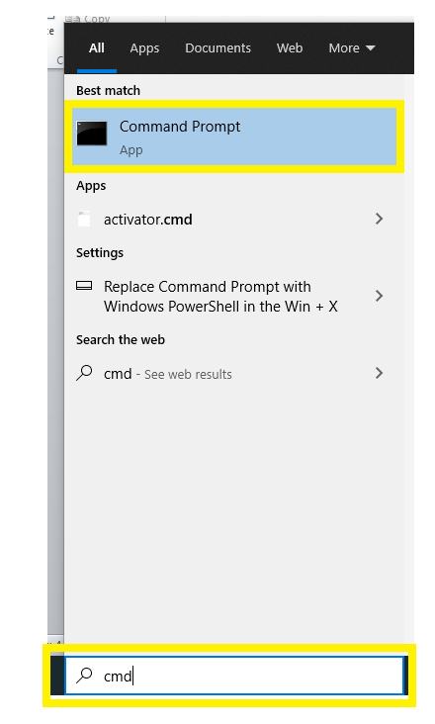
- The following window will appear. Type "ipconfig" (without the quotes) to access the private IP address information.
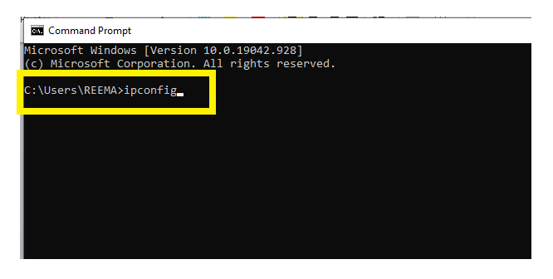
- It will display the following information.
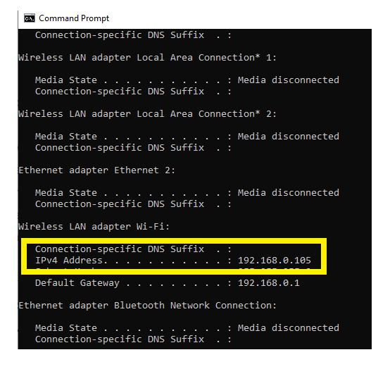
On a Mac:
- Go to System Preferences
2.Click on the network option.
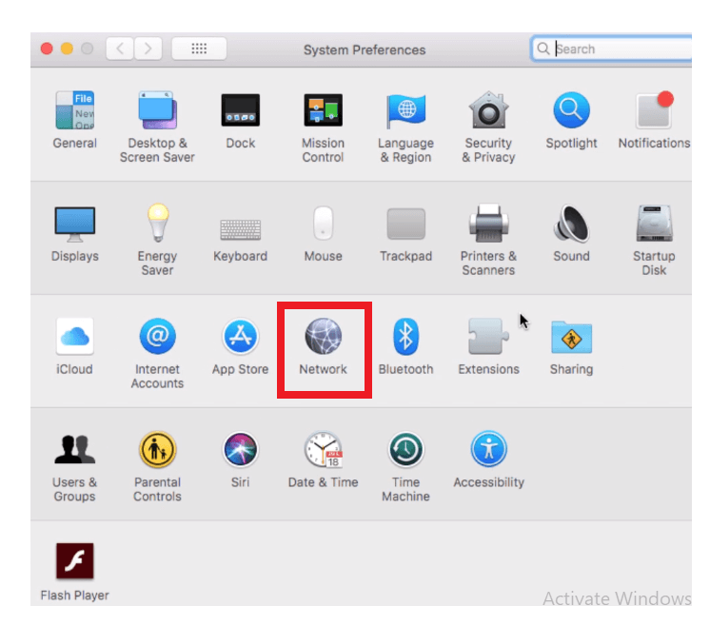
3.It will display the information regarding your private IP address.
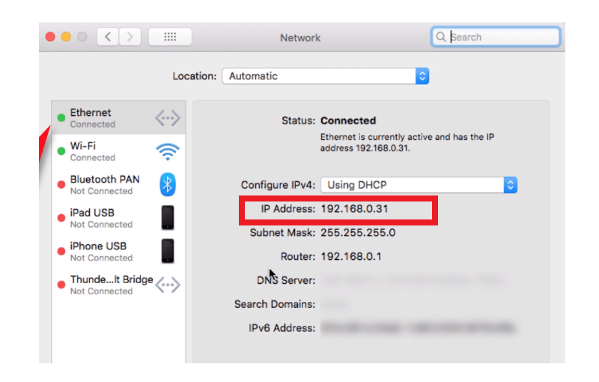

IP address security threats
Cybercriminals or digital crackers various ways to hack your IP address. The two commonly used techniques include social engineering and online stalking.

Social engineering
Hackers can practice social engineering techniques to trick you into disclosing your device's IP address. For example, they will connect you through email, Skype, or a similar instantaneous messaging app, that accepts IP addresses to communicate and pass information.
If you chat with these anonymous people using these messaging applications, it is essential to note that they can get your IP address. Cybercriminals can use a third-party tool named Skype Resolver, with the help of which they can locate your IP address using your username.

Online stalking
Attackers can get crack your IP address by simply tracking your online activities. Any online activity can disclose your IP address, i.e., from using an instant messaging app to playing online games to discussing a topic on any digital websites and forums. Once they gain access to your IP address, criminals can visit an IP address tracking website (whatismyipaddress.com), they will enter your IP address there, and in no seconds, they can track your current location.
They won't stop till this; they can further cross-check it with other available information to verify whether the IP address is connected with you particularly. Social networking sites such as instagram, LinkedIn, facebook are used to verify the information of your location gathered by the attacker.
11. Explain the categories of Networks.
A computer network is a group of computers linked to each other that enables the computer to communicate with another computer and share their resources, data, and applications.
A computer network can be categorized by their size. A computer network is mainly of four types:
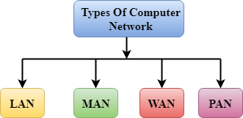
- LAN(Local Area Network)
- PAN(Personal Area Network)
- MAN(Metropolitan Area Network)
- WAN(Wide Area Network)

LAN(Local Area Network)
- Local Area Network is a group of computers connected to each other in a small area such as building, office.
- LAN is used for connecting two or more personal computers through a communication medium such as twisted pair, coaxial cable, etc.
- It is less costly as it is built with inexpensive hardware such as hubs, network adapters, and ethernet cables.
- The data is transferred at an extremely faster rate in Local Area Network.
- Local Area Network provides higher security.
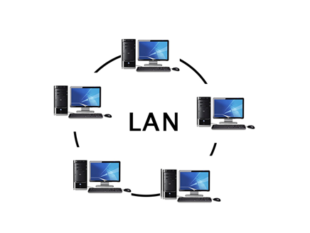

PAN(Personal Area Network)
- Personal Area Network is a network arranged within an individual person, typically within a range of 10 meters.
- Personal Area Network is used for connecting the computer devices of personal use is known as Personal Area Network.
- Thomas Zimmerman was the first research scientist to bring the idea of the Personal Area Network.
- Personal Area Network covers an area of 30 feet.
- Personal computer devices that are used to develop the personal area network are the laptop, mobile phones, media player and play stations.
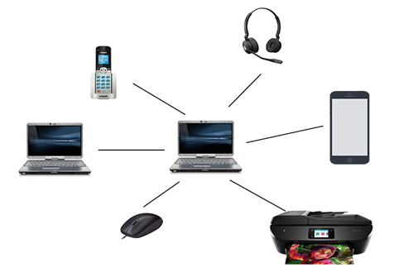
There are two types of Personal Area Network:
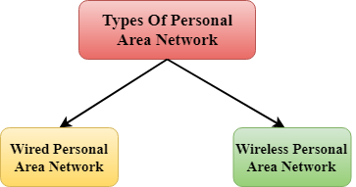
- Wired Personal Area Network
- Wireless Personal Area Network
Wireless Personal Area Network: Wireless Personal Area Network is developed by simply using wireless technologies such as WiFi, Bluetooth. It is a low range network.
10 Sec
History of Java
Wired Personal Area Network: Wired Personal Area Network is created by using the USB.

Examples Of Personal Area Network:
- Body Area Network: Body Area Network is a network that moves with a person. For example, a mobile network moves with a person. Suppose a person establishes a network connection and then creates a connection with another device to share the information.
- Offline Network: An offline network can be created inside the home, so it is also known as a home network. A home network is designed to integrate the devices such as printers, computer, television but they are not connected to the internet.
- Small Home Office: It is used to connect a variety of devices to the internet and to a corporate network using a VPN

MAN(Metropolitan Area Network)
- A metropolitan area network is a network that covers a larger geographic area by interconnecting a different LAN to form a larger network.
- Government agencies use MAN to connect to the citizens and private industries.
- In MAN, various LANs are connected to each other through a telephone exchange line.
- The most widely used protocols in MAN are RS-232, Frame Relay, ATM, ISDN, OC-3, ADSL, etc.
- It has a higher range than Local Area Network(LAN).
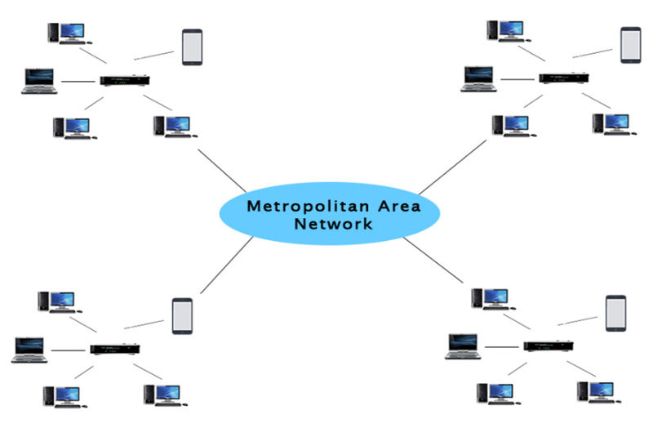

Uses Of Metropolitan Area Network:
- MAN is used in communication between the banks in a city.
- It can be used in an Airline Reservation.
- It can be used in a college within a city.
- It can also be used for communication in the military.

WAN(Wide Area Network)
- A Wide Area Network is a network that extends over a large geographical area such as states or countries.
- A Wide Area Network is quite bigger network than the LAN.
- A Wide Area Network is not limited to a single location, but it spans over a large geographical area through a telephone line, fibre optic cable or satellite links.
- The internet is one of the biggest WAN in the world.
- A Wide Area Network is widely used in the field of Business, government, and education.
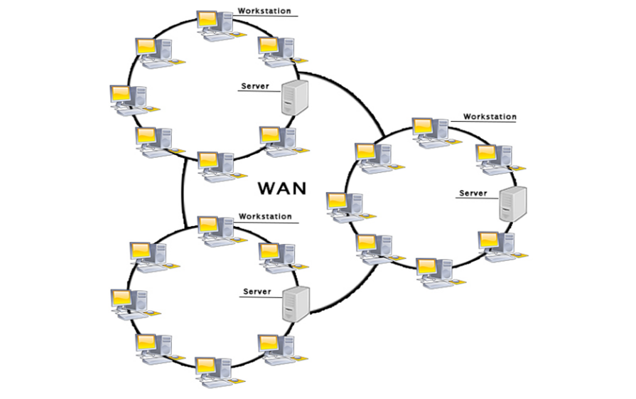

Examples Of Wide Area Network:
- Mobile Broadband: A 4G network is widely used across a region or country.
- Last mile: A telecom company is used to provide the internet services to the customers in hundreds of cities by connecting their home with fiber.
- Private network: A bank provides a private network that connects the 44 offices. This network is made by using the telephone leased line provided by the telecom company.

Advantages Of Wide Area Network:
Following are the advantages of the Wide Area Network:
- Geographical area: A Wide Area Network provides a large geographical area. Suppose if the branch of our office is in a different city then we can connect with them through WAN. The internet provides a leased line through which we can connect with another branch.
- Centralized data: In case of WAN network, data is centralized. Therefore, we do not need to buy the emails, files or back up servers.
- Get updated files: Software companies work on the live server. Therefore, the programmers get the updated files within seconds.
- Exchange messages: In a WAN network, messages are transmitted fast. The web application like Facebook, Whatsapp, Skype allows you to communicate with friends.
- Sharing of software and resources: In WAN network, we can share the software and other resources like a hard drive, RAM.
- Global business: We can do the business over the internet globally.
- High bandwidth: If we use the leased lines for our company then this gives the high bandwidth. The high bandwidth increases the data transfer rate which in turn increases the productivity of our company.

Disadvantages of Wide Area Network:
The following are the disadvantages of the Wide Area Network:
- Security issue: A WAN network has more security issues as compared to LAN and MAN network as all the technologies are combined together that creates the security problem.
- Needs Firewall & antivirus software: The data is transferred on the internet which can be changed or hacked by the hackers, so the firewall needs to be used. Some people can inject the virus in our system so antivirus is needed to protect from such a virus.
- High Setup cost: An installation cost of the WAN network is high as it involves the purchasing of routers, switches.
- Troubleshooting problems: It covers a large area so fixing the problem is difficult.

Internetwork
- An internetwork is defined as two or more computer network LANs or WAN or computer network segments are connected using devices, and they are configured by a local addressing scheme. This process is known as internetworking.
- An interconnection between public, private, commercial, industrial, or government computer networks can also be defined as internetworking.
- An internetworking uses the internet protocol.
- The reference model used for internetworking is Open System Interconnection(OSI).

Types Of Internetwork:
1. Extranet: An extranet is a communication network based on the internet protocol such as Transmission Control protocol and internet protocol. It is used for information sharing. The access to the extranet is restricted to only those users who have login credentials. An extranet is the lowest level of internetworking. It can be categorized as MAN, WAN or other computer networks. An extranet cannot have a single LAN, atleast it must have one connection to the external network.
2. Intranet: An intranet is a private network based on the internet protocol such as Transmission Control protocol and internet protocol. An intranet belongs to an organization which is only accessible by the organization's employee or members. The main aim of the intranet is to share the information and resources among the organization employees. An intranet provides the facility to work in groups and for teleconferences.

Intranet advantages:
- Communication: It provides a cheap and easy communication. An employee of the organization can communicate with another employee through email, chat.
- Time-saving: Information on the intranet is shared in real time, so it is time-saving.
- Collaboration: Collaboration is one of the most important advantage of the intranet. The information is distributed among the employees of the organization and can only be accessed by the authorized user.
- Platform independency: It is a neutral architecture as the computer can be connected to another device with different architecture.
- Cost effective: People can see the data and documents by using the browser and distributes the duplicate copies over the intranet. This leads to a reduction in the cost.
12. Explain in detail about the functions of data link layer.
DATA LINK LAYER
Data Link Layer is second layer of OSI Layered Model. This layer is one of the most complicated layers and has complex functionalities and liabilities. Data link layer hides the details of underlying hardware and represents itself to upper layer as the medium to communicate.
Data link layer works between two hosts which are directly connected in some sense. This direct connection could be point to point or broadcast. Systems on broadcast network are said to be on same link. The work of data link layer tends to get more complex when it is dealing with multiple hosts on single collision domain.
Data link layer is responsible for converting data stream to signals bit by bit and to send that over the underlying hardware. At the receiving end, Data link layer picks up data from hardware which are in the form of electrical signals, assembles them in a recognizable frame format, and hands over to upper layer.
Data link layer has two sub-layers:
- Logical Link Control: It deals with protocols, flow-control, and error control
- Media Access Control: It deals with actual control of media

Functionality of Data-link Layer
Data link layer does many tasks on behalf of upper layer. These are:
- Framing
Data-link layer takes packets from Network Layer and encapsulates them into Frames.Then, it sends each frame bit-by-bit on the hardware. At receiver’ end, data link layer picks up signals from hardware and assembles them into frames.
- Addressing
Data-link layer provides layer-2 hardware addressing mechanism. Hardware address is assumed to be unique on the link. It is encoded into hardware at the time of manufacturing.
- Synchronization
When data frames are sent on the link, both machines must be synchronized in order to transfer to take place.
- Error Control
Sometimes signals may have encountered problem in transition and the bits are flipped. These errors are detected and attempted to recover actual data bits. It also provides error reporting mechanism to the sender.
- Flow Control
Stations on same link may have different speed or capacity. Data-link layer ensures flow control that enables both machine to exchange data on same speed.
- Multi-Access
When host on the shared link tries to transfer the data, it has a high probability of collision. Data-link layer provides mechanism such as CSMA/CD to equip capability of accessing a shared media among multiple Systems.

13.Explain in detail about Topology in network.
Topology defines the structure of the network of how all the components are interconnected to each other. There are two types of topology: physical and logical topology.
Physical topology is the geometric representation of all the nodes in a network.
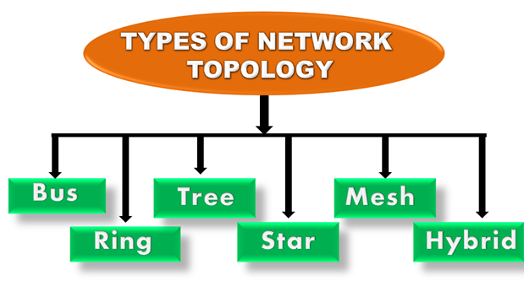

Bus Topology
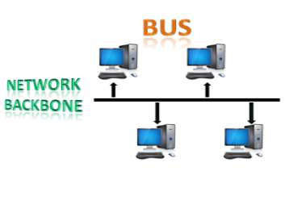
- The bus topology is designed in such a way that all the stations are connected through a single cable known as a backbone cable.
- Each node is either connected to the backbone cable by drop cable or directly connected to the backbone cable.
- When a node wants to send a message over the network, it puts a message over the network. All the stations available in the network will receive the message whether it has been addressed or not.
- The bus topology is mainly used in 802.3 (ethernet) and 802.4 standard networks.
- The configuration of a bus topology is quite simpler as compared to other topologies.
- The backbone cable is considered as a "single lane" through which the message is broadcast to all the stations.
- The most common access method of the bus topologies is CSMA (Carrier Sense Multiple Access).
CSMA: It is a media access control used to control the data flow so that data integrity is maintained, i.e., the packets do not get lost. There are two alternative ways of handling the problems that occur when two nodes send the messages simultaneously.
- CSMA CD: CSMA CD (Collision detection) is an access method used to detect the collision. Once the collision is detected, the sender will stop transmitting the data. Therefore, it works on "recovery after the collision".
- CSMA CA: CSMA CA (Collision Avoidance) is an access method used to avoid the collision by checking whether the transmission media is busy or not. If busy, then the sender waits until the media becomes idle. This technique effectively reduces the possibility of the collision. It does not work on "recovery after the collision".

Advantages of Bus topology:
- Low-cost cable: In bus topology, nodes are directly connected to the cable without passing through a hub. Therefore, the initial cost of installation is low.
- Moderate data speeds: Coaxial or twisted pair cables are mainly used in bus-based networks that support upto 10 Mbps.
- Familiar technology: Bus topology is a familiar technology as the installation and troubleshooting techniques are well known, and hardware components are easily available.
- Limited failure: A failure in one node will not have any effect on other nodes.

Disadvantages of Bus topology:
- Extensive cabling: A bus topology is quite simpler, but still it requires a lot of cabling.
- Difficult troubleshooting: It requires specialized test equipment to determine the cable faults. If any fault occurs in the cable, then it would disrupt the communication for all the nodes.
- Signal interference: If two nodes send the messages simultaneously, then the signals of both the nodes collide with each other.
- Reconfiguration difficult: Adding new devices to the network would slow down the network.
- Attenuation: Attenuation is a loss of signal leads to communication issues. Repeaters are used to regenerate the signal.

Ring Topology
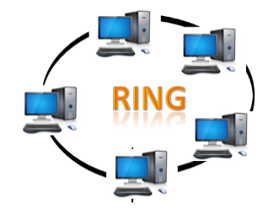
- Ring topology is like a bus topology, but with connected ends.
- The node that receives the message from the previous computer will retransmit to the next node.
- The data flows in one direction, i.e., it is unidirectional.
- The data flows in a single loop continuously known as an endless loop.
- It has no terminated ends, i.e., each node is connected to other node and having no termination point.
- The data in a ring topology flow in a clockwise direction.
- The most common access method of the ring topology is token passing.
  - Token passing: It is a network access method in which token is passed from one node to another node.
  - Token: It is a frame that circulates around the network.

Working of Token passing
- A token moves around the network, and it is passed from computer to computer until it reaches the destination.
- The sender modifies the token by putting the address along with the data.
- The data is passed from one device to another device until the destination address matches. Once the token received by the destination device, then it sends the acknowledgment to the sender.
- In a ring topology, a token is used as a carrier.

Advantages of Ring topology:
- Network Management: Faulty devices can be removed from the network without bringing the network down.
- Product availability: Many hardware and software tools for network operation and monitoring are available.
- Cost: Twisted pair cabling is inexpensive and easily available. Therefore, the installation cost is very low.
- Reliable: It is a more reliable network because the communication system is not dependent on the single host computer.

Disadvantages of Ring topology:
- Difficult troubleshooting: It requires specialized test equipment to determine the cable faults. If any fault occurs in the cable, then it would disrupt the communication for all the nodes.
- Failure: The breakdown in one station leads to the failure of the overall network.
- Reconfiguration difficult: Adding new devices to the network would slow down the network.
- Delay: Communication delay is directly proportional to the number of nodes. Adding new devices increases the communication delay.

Star Topology
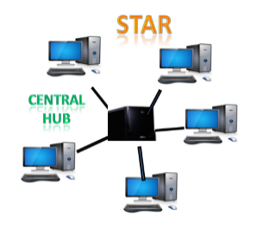
- Star topology is an arrangement of the network in which every node is connected to the central hub, switch or a central computer.
- The central computer is known as a server, and the peripheral devices attached to the server are known as clients.
- Coaxial cable or RJ-45 cables are used to connect the computers.
- Hubs or Switches are mainly used as connection devices in a physical star topology.
- Star topology is the most popular topology in network implementation.

Advantages of Star topology
- Efficient troubleshooting: Troubleshooting is quite efficient in a star topology as compared to bus topology. In a bus topology, the manager has to inspect the kilometers of cable. In a star topology, all the stations are connected to the centralized network. Therefore, the network administrator has to go to the single station to troubleshoot the problem.
- Network control: Complex network control features can be easily implemented in the star topology. Any changes made in the star topology are automatically accommodated.
- Limited failure: As each station is connected to the central hub with its own cable, therefore failure in one cable will not affect the entire network.
- Familiar technology: Star topology is a familiar technology as its tools are cost-effective.
- Easily expandable: It is easily expandable as new stations can be added to the open ports on the hub.
- Cost effective: Star topology networks are cost-effective as it uses inexpensive coaxial cable.
- High data speeds: It supports a bandwidth of approx 100Mbps. Ethernet 100BaseT is one of the most popular Star topology networks.

Disadvantages of Star topology
- A Central point of failure: If the central hub or switch goes down, then all the connected nodes will not be able to communicate with each other.
- Cable: Sometimes cable routing becomes difficult when a significant amount of routing is required.

Tree topology
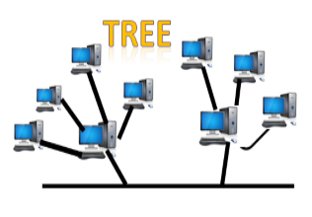
- Tree topology combines the characteristics of bus topology and star topology.
- A tree topology is a type of structure in which all the computers are connected with each other in hierarchical fashion.
- The top-most node in tree topology is known as a root node, and all other nodes are the descendants of the root node.
- There is only one path exists between two nodes for the data transmission. Thus, it forms a parent-child hierarchy.

Advantages of Tree topology
- Support for broadband transmission: Tree topology is mainly used to provide broadband transmission, i.e., signals are sent over long distances without being attenuated.
- Easily expandable: We can add the new device to the existing network. Therefore, we can say that tree topology is easily expandable.
- Easily manageable: In tree topology, the whole network is divided into segments known as star networks which can be easily managed and maintained.
- Error detection: Error detection and error correction are very easy in a tree topology.
- Limited failure: The breakdown in one station does not affect the entire network.
- Point-to-point wiring: It has point-to-point wiring for individual segments.

Disadvantages of Tree topology
- Difficult troubleshooting: If any fault occurs in the node, then it becomes difficult to troubleshoot the problem.
- High cost: Devices required for broadband transmission are very costly.
- Failure: A tree topology mainly relies on main bus cable and failure in main bus cable will damage the overall network.
- Reconfiguration difficult: If new devices are added, then it becomes difficult to reconfigure.

Mesh topology
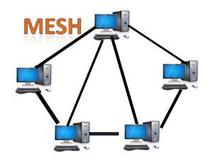
- Mesh technology is an arrangement of the network in which computers are interconnected with each other through various redundant connections.
- There are multiple paths from one computer to another computer.
- It does not contain the switch, hub or any central computer which acts as a central point of communication.
- The Internet is an example of the mesh topology.
- Mesh topology is mainly used for WAN implementations where communication failures are a critical concern.
- Mesh topology is mainly used for wireless networks.
- Mesh topology can be formed by using the formula:
Number of cables = (n*(n-1))/2;
Where n is the number of nodes that represents the network.
Mesh topology is divided into two categories:
- Fully connected mesh topology
- Partially connected mesh topology
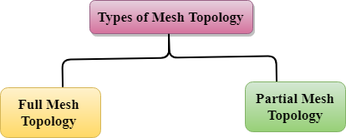
- Full Mesh Topology: In a full mesh topology, each computer is connected to all the computers available in the network.
- Partial Mesh Topology: In a partial mesh topology, not all but certain computers are connected to those computers with which they communicate frequently.

Advantages of Mesh topology:
Reliable: The mesh topology networks are very reliable as if any link breakdown will not affect the communication between connected computers.
Fast Communication: Communication is very fast between the nodes.
Easier Reconfiguration: Adding new devices would not disrupt the communication between other devices.

Disadvantages of Mesh topology
- Cost: A mesh topology contains a large number of connected devices such as a router and more transmission media than other topologies.
- Management: Mesh topology networks are very large and very difficult to maintain and manage. If the network is not monitored carefully, then the communication link failure goes undetected.
- Efficiency: In this topology, redundant connections are high that reduces the efficiency of the network.

Hybrid Topology
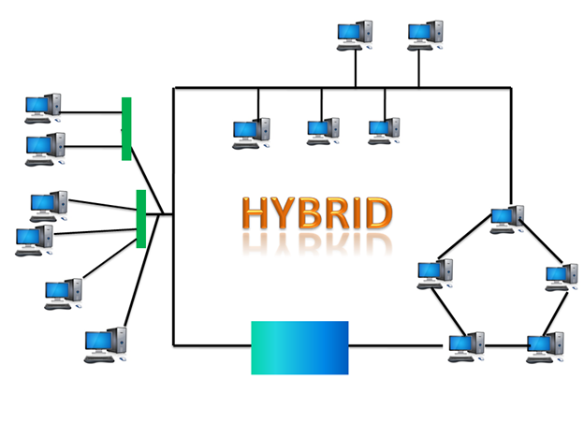
- The combination of various different topologies is known as Hybrid topology.
- A Hybrid topology is a connection between different links and nodes to transfer the data.
- When two or more different topologies are combined together is termed as Hybrid topology and if similar topologies are connected with each other will not result in Hybrid topology. For example, if there exist a ring topology in one branch of ICICI bank and bus topology in another branch of ICICI bank, connecting these two topologies will result in Hybrid topology.

Advantages of Hybrid Topology
- Reliable: If a fault occurs in any part of the network will not affect the functioning of the rest of the network.
- Scalable: Size of the network can be easily expanded by adding new devices without affecting the functionality of the existing network.
- Flexible: This topology is very flexible as it can be designed according to the requirements of the organization.
- Effective: Hybrid topology is very effective as it can be designed in such a way that the strength of the network is maximized and weakness of the network is minimized.

Disadvantages of Hybrid topology
- Complex design: The major drawback of the Hybrid topology is the design of the Hybrid network. It is very difficult to design the architecture of the Hybrid network.
- Costly Hub: The Hubs used in the Hybrid topology are very expensive as these hubs are different from usual Hubs used in other topologies.
- Costly infrastructure: The infrastructure cost is very high as a hybrid network requires a lot of cabling, network devices, etc.
14. Explain in detail about the types of Protocols.
PROTOCOLS
There are various types of protocols that support a major and compassionate role in communicating with different devices across the network. These are:
- Transmission Control Protocol (TCP)
- Internet Protocol (IP)
- User Datagram Protocol (UDP)
- Post office Protocol (POP)
- Simple mail transport Protocol (SMTP)
- File Transfer Protocol (FTP)
- Hyper Text Transfer Protocol (HTTP)
- Hyper Text Transfer Protocol Secure (HTTPS)
- Telnet
- Gopher
Transmission Control Protocol (TCP): TCP is a popular communication protocol which is used for communicating over a network. It divides any message into series of packets that are sent from source to destination and there it gets reassembled at the destination.
Internet Protocol (IP): IP is designed explicitly as addressing protocol. It is mostly used with TCP. The IP addresses in packets help in routing them through different nodes in a network until it reaches the destination system. TCP/IP is the most popular protocol connecting the networks.
User Datagram Protocol (UDP): UDP is a substitute communication protocol to Transmission Control Protocol implemented primarily for creating loss-tolerating and low-latency linking between different applications.
Post office Protocol (POP): POP3 is designed for receiving incoming E-mails.
Simple mail transport Protocol (SMTP): SMTP is designed to send and distribute outgoing E-Mail.
File Transfer Protocol (FTP): FTP allows users to transfer files from one machine to another. Types of files may include program files, multimedia files, text files, and documents, etc.
Hyper Text Transfer Protocol (HTTP): HTTP is designed for transferring a hypertext among two or more systems. HTML tags are used for creating links. These links may be in any form like text or images. HTTP is designed on Client-server principles which allow a client system for establishing a connection with the server machine for making a request. The server acknowledges the request initiated by the client and responds accordingly.
Hyper Text Transfer Protocol Secure (HTTPS): HTTPS is abbreviated as Hyper Text Transfer Protocol Secure is a standard protocol to secure the communication among two computers one using the browser and other fetching data from web server. HTTP is used for transferring data between the client browser (request) and the web server (response) in the hypertext format, same in case of HTTPS except that the transferring of data is done in an encrypted format. So it can be said that https thwart hackers from interpretation or modification of data throughout the transfer of packets.
Telnet: Telnet is a set of rules designed for connecting one system with another. The connecting process here is termed as remote login. The system which requests for connection is the local computer, and the system which accepts the connection is the remote computer.
Gopher: Gopher is a collection of rules implemented for searching, retrieving as well as displaying documents from isolated sites. Gopher also works on the client/server principle.
Some other popular protocols act as co-functioning protocols associated with these primary protocols for core functioning. These are:
- ARP (Address Resolution Protocol)
- DHCP (Dynamic Host Configuration Protocol)
- IMAP4 (Internet Message Access Protocol)
- SIP (Session Initiation Protocol)
- RTP (Real-Time Transport Protocol)
- RLP (Resource Location Protocol)
- RAP (Route Access Protocol)
- L2TP (Layer Two Tunnelling Protocol)
- PPTP (Point To Point Tunnelling Protocol)
- SNMP (Simple Network Management Protocol)
- TFTP (Trivial File Transfer Protocol)
15. Differentiate packet switching and circuit switching.
The important difference between circuit switching and packet switching
Parameter | Circuit Switching | Packet Switching
Number of connection | It has one single connection which leads to a single path connecting two points. | In this switching, the packet is simply data with many smaller units along with a header.
Nature of connection | Without a connection, this switching cannot work. So it is connection-oriented. | This switching can work without a dedicated connection.
A specific layer of the OSI model | It exists in the physical layer. | It exists at the network layer.
Nature of path | This follows a uniform path throughout the session. | It has no uniform path specified from end to end session.
Route | It has a circuit route needs to be established for the data transmission. | Each packet contains the information which needs to be processed through the dynamic route.
Application | Mostly this switching is ideal for voice communication. | Mostly this switching is useful for data transmission.
Delay | It may have a call setup delay. | It may have a Packet transmission delay.
Type of Bandwidth | It has fixed Bandwidth. | It has dynamic bandwidth.

